SyncUp AI: Automated Meeting Summarizer

Mr. Sainath Pawar  Pillai HOC College of Engineering and Technology, Rasayani  sainathnp22hcompe@stud  ent.mes.ac.in | Mr. Teja Poosa  Pillai HOC College of Engineering and Technology, Rasayani  tejalp22hcompe@stude  nt.mes.ac.in | Mr. Shantanu Patil  Pillai HOC College of Engineering and Technology, Rasayani  shantanusp22hcompe@stu  dent.mes.ac.in | Ms. Rajshree Gadhave  Pillai HOC College of Engineering and Technology, Rasayani  rgadhave@mes.ac.in

Abstract—SyncUp is an intelligent smart platform that eradicates meeting inefficiency by Transcription, knowledge management, and summarization. The system harmonizes smoothly with such leading video conferencing tools as Zoom, Microsoft Teams, and Google Meet to give high quality and speaker recognition transcription in real time. Leveraging truly modern large language models, SyncUp smartly summarises hours of conversation. brief accounts, automatically swallows out major points of discussion, conclusions reached and action items where each of them has assigned owners.
The platform has a secure knowledge base, searchable and enables teams to access the past on demand. Experiences and dialogue. Enhanced features, such as sentiment analysis in order to measure meeting tone, are given. The ability to monitor participation using speaker analytics, strong CRM and project integrations Such management tools as Jira and Salesforce. As a major client, they have been focusing on enterprise and SMB clients .The SyncUp enables organizations to turn unstructured information about meetings into usable data. intelligence, accountability involvement, raising project velocity, and relief of teams to work on Creation through execution, as opposed to manual note taking. Having an enterprise grade scale and security focus, and workflow integration and seamless workflow integration, SyncUp offers an end-to-end solution of content capture and operation Rights square as the operationalisation of organizational knowledge

Keywords: AI Meeting Assistant, Meeting Summarization, Real-Time Transcription, Natural NLP, Action Item Tracking, Knowledge Management..

- INTRODUCTION

Meetings play a crucial role in collaboration and decision-making, yet the valuable insights they generate often remain unstructured and difficult to retrieve. Decisions, follow-ups, and contextual details tend to be hidden within lengthy conversations or informal notes, resulting in information loss, weak accountability, and limited knowledge continuity across teams

SyncUp addresses this gap by functioning as an AI-driven meeting assistant that automatically converts spoken dialogue into structured artifacts such as summaries, action items, and highlights. Using speech processing and natural language understanding, the system transforms raw audio into concise, meaningful representations that support post-meeting review and execution. Beyond summarization, SyncUp incorporates retrieval-augmented generation to enable natural language queries over past meetings, turning archived transcripts into an accessible knowledge resource rather than passive storage.

A key differentiator of SyncUp is its privacy-preserving architecture. Instead of relying on cloud-based language models, the system employs locally hosted LLMs via Ollama, reducing cost and ensuring that sensitive communication data remains on-premise. The integration of a vector database further enables semantic search across historical content, while calendar integration and automated notifications streamline workflow management.

In doing so, SyncUp contributes to the growing domain of computational meeting analytics by combining transcription, summarization, and knowledge retrieval in a unified pipeline. The platform benefits organizations seeking improved decision traceability, better task coordination, and persistent access to institutional knowledge, demonstrating how AI can enhance the effectiveness of digital collaboration environments.

- PRIOR STUDIES

Recent developments in meeting analysis research focus on automating transcription, summarization, and knowledge extraction from spoken dialogue through speech recognition and natural language processing pipelines. Deep learning models such as Whisper and transformer-based summarizers have demonstrated reliable performance in producing coherent abstractions of lengthy discussions, while retrieval-augmented architectures enhance factual consistency by grounding responses in historical meeting data. Local inference frameworks, including Ollama and similar on-device LLM deployments, are gaining traction as privacy-sensitive alternatives to cloud APIs. Vector databases and embedding techniques further enable semantic search across archival transcripts, though challenges persist in domain adaptation, speaker diarization, context tracking, and evaluation metrics for conversational summaries.. In addition, studies increasingly emphasize multi-modal signals—such as speaker tone, pacing, and meeting agenda alignment—as complementary information sources for improving downstream reasoning. There is also growing interest in integrating task management and notification workflows directly into meeting analysis pipelines to reduce manual follow-up effort and enhance coordination. These research directions collectively reflect a shift toward more holistic meeting intelligence systems that bridge conversational understanding with actionable organizational outcomes.

- RELATED WORK

Research on automated meeting analysis has expanded with advances in speech recognition and natural language processing. Studies investigate how spoken interactions can be converted into structured information through transcription, summarization, and retrieval pipelines, often implemented using Python-based toolchains for preprocessing and diarization.

Recent work highlights the effectiveness of transformer-based models and speech-to-text systems, such as Whisper and DeepSpeech, in generating accurate transcripts and enabling abstractive summarization of meeting dialogue. Retrieval-augmented methods further support semantic search across historical transcripts by integrating language models with vector databases and embedding techniques.

Several approaches utilize conferencing platform APIs and webhook integrations to collect meeting audio and metadata, while on-device inference frameworks have been explored to address privacy and compliance concerns. Neural architectures, particularly attention-based models, show promise for identifying agenda shifts, action items, and discourse patterns within long-form multi-speaker conversations.

Despite notable progress, challenges persist in handling overlapping dialogue, domain-specific terminology, multilingual settings, and reliable evaluation metrics for conversational summarization. Current research trends emphasize privacy-preserving analytics, personalized summarization, and scalable multilingual systems suited for real-world organizational environments.

- METHODOLOGY
The system follows a modular and event-driven design composed of several interconnected components. Its workflow progresses in an organized manner, beginning with user access control and moving through recording, processing, storage, retrieval, and final notification mechanisms. Together, these stages form a continuous loop that supports automated meeting intelligence.
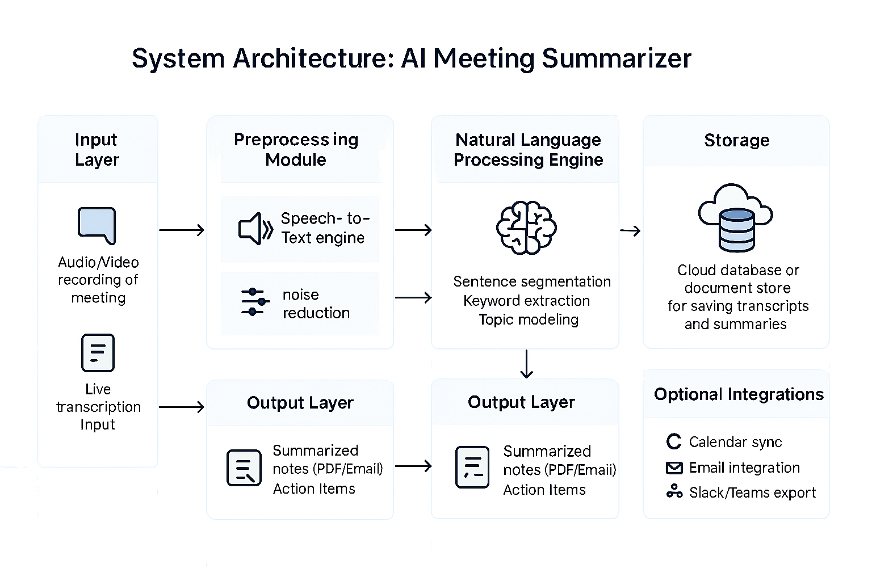
Fig:1(Methodology Of SyncUp)

1. User Authentication and Access Control
The first phase involves verifying the user’s identity. Individuals either sign in or create an account, and the authentication framework manages session handling and credential validation. After successful login, the system retrieves the user’s profile to personalize subsequent operations.
2. Meeting Initialization and Audio Capture
Once authenticated, the user proceeds to configure a meeting. At this point, an audio recorder is activated and the meeting begins. This event triggers real-time transcription, signaling the start of the system’s analytical pipeline and later storage processes.
3. Intelligent Processing and Analysis
The main analytical engine operates in this phase. Incoming audio is transcribed using speech-to-text techniques, after which the text is refined into concise summaries and relevant insights. Additional analysis detects tasks and action items that originate from the discussion..
4. Central Storage and Information Retrieval
This stage acts as the nucleus of the platform, responsible for receiving processed material and supplying data when requested. It contains multiple layers, including:
• Database storage: a relational storage system for user details, meeting information, summaries, and extracted tasks.
•Vector Database: a vector-based storage layer that converts transcripts into high-dimensional embeddings for semantic querying.
•Meeting Meeting Management: and a management layer that coordinates data access and updates.

- RESULTS
The SyncUp system was successfully implemented using a combination of speech processing, natural language understanding, and retrieval-based techniques. The generated results demonstrated clear improvements in how meeting data can be interpreted and organized, providing structured insights from previously unstructured conversations. By converting recorded meeting audio into transcripts, summaries, and action items, the system enabled users to review discussions efficiently and identify key decisions or follow-ups. In addition, semantic search and intelligent querying helped uncover patterns across multiple meetings, supporting long-term knowledge retention and more informed decision-making.
As organizations increasingly rely on virtual collaboration, meetings generate large volumes of conversational data that often go unused after discussions conclude. Extracting structured knowledge from these interactions presents both practical and analytical challenges, as spoken content contains overlapping dialogue, context shifts, and implicit decision-making cues. SyncUp addresses this issue by transforming raw audio streams into readable and searchable information layers that preserve both semantic meaning and organizational intent

1. Automatic Audio Recording
The system begins its workflow by capturing live audio as soon as a meeting starts, either through scheduled sessions or manual initiation. This recording process relies on an integrated MeetingBaaS layer that ensures uninterrupted and high-quality audio intake throughout the discussion. The captured audio is treated as the foundational data source upon which all later analysis is built. By preserving the chronological structure of the conversation, the system maintains a reliable representation of how ideas evolve in real time. This stage is essential for guaranteeing that the final summaries and extracted insights accurately reflect the meeting as it occurred..
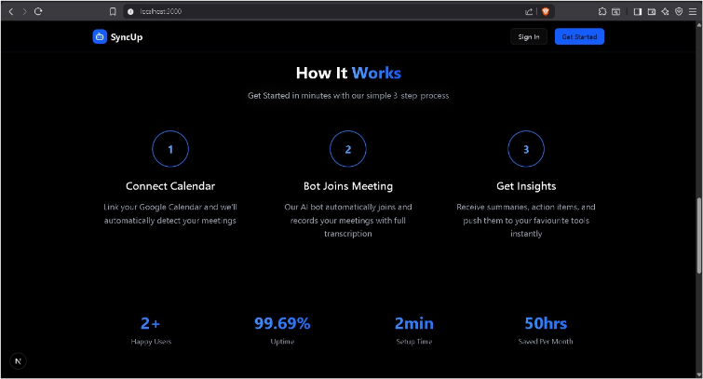
Figure:3()
2. Real-Time Transcription (Speech-to-Text)
Once audio capture is underway, the next step converts spoken dialogue into structured text using a speech-to-text model optimized for multi-speaker settings. Each segment of speech is mapped to a timestamp and, when possible, linked to individual speakers, supporting better clarity during later review. This transformation allows the system to process meeting content in a machine-readable format while maintaining a natural flow that resembles the original speech. Real-time transcription also minimizes latency between audio input and textual output, enabling downstream modules to begin processing without delay. This step serves as the linguistic backbone of the entire meeting analysis pipeline..
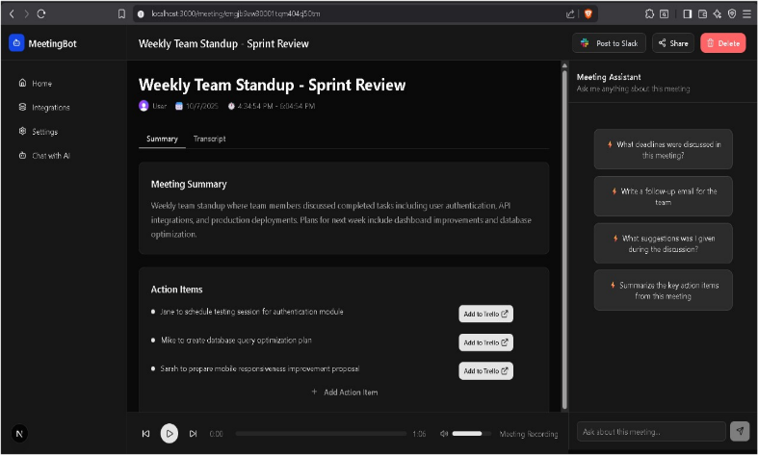
Figure:4(Emoji Analysis)

3. AI-Based Summarization
After a complete transcript is available, an AI summarization engine condenses the long-form conversation into a clear and coherent narrative. Transformer-based models identify the central themes, major decisions, and conversational turning points, producing a summary that captures the essence of the discussion. Instead of extracting isolated sentences, the models generate a fluent, context-aware overview that reduces the need to revisit long transcripts. This stage helps users understand the outcome of a meeting in a matter of minutes, which is especially valuable for large teams or stakeholders who could not attend. Summaries produced in this step are crafted to be both concise and faithful to the original content...
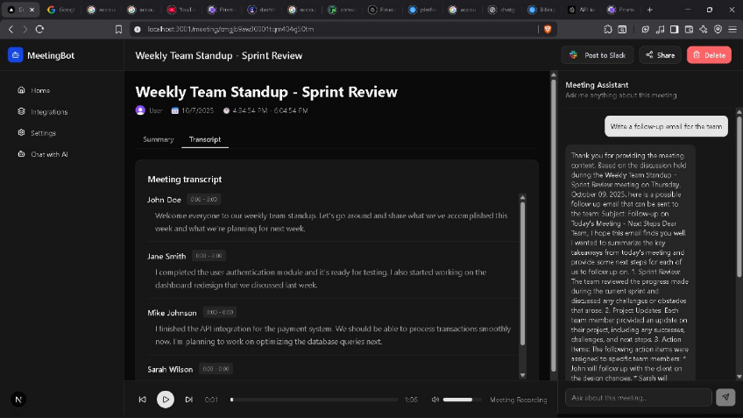
Figure:5(Ai Summary)

4. Action Item Extraction
Parallel to summarization, the system identifies tasks, deadlines, commitments, and decisions that require follow-up. NLP models scan the transcript for phrases indicating responsibility or next steps, then categorize them into actionable units. These items are stored with associated metadata, such as the responsible person or expected completion time. By systematically extracting obligations, the system reduces the chance that important tasks are overlooked or forgotten after the meeting ends. This component supports project continuity and ensures that meetings translate into tangible outcomes.
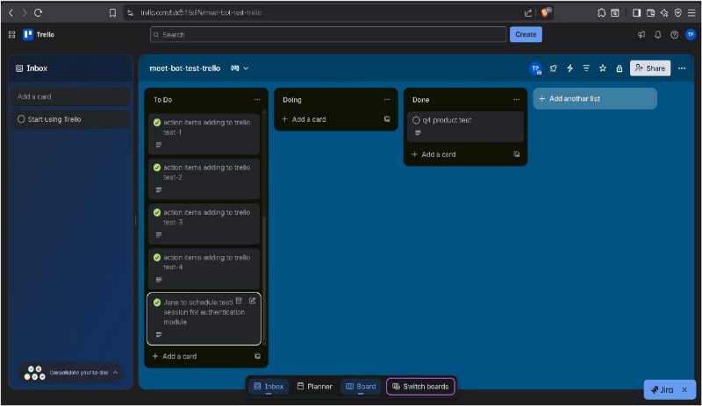
Figure:6(Trello)

5. Intelligent Chat (Retrieval-Augmented Querying)
The intelligent chat interface allows users to ask questions about past meetings and receive grounded, contextually accurate responses. Rather than generating information from scratch, the system retrieves relevant segments of stored transcripts and summaries using a retrieval-augmented generation method. This ensures that responses are always anchored in factual meeting content. The interface functions like a conversational gateway to the organization’s knowledge archive, simplifying the process of finding specific details buried in earlier discussions. This capability enhances institutional memory and supports decision-making across long-term projects.
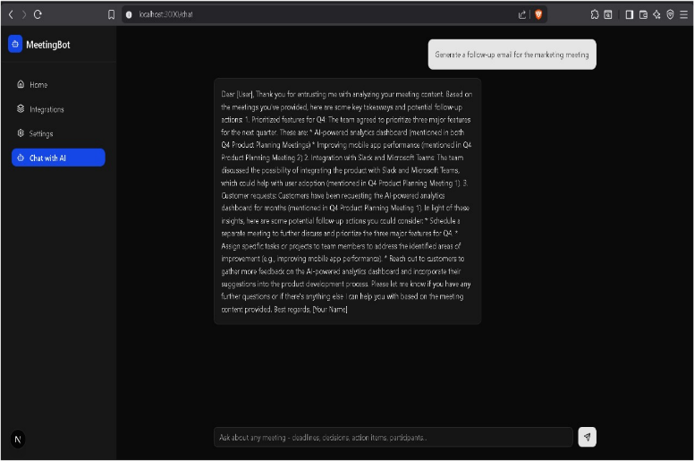
Figure:7(AI Chatbot)

6. Cross-Meeting Semantic Search
To support natural and flexible information retrieval, meeting transcripts and summaries are converted into high-dimensional vector embeddings. These embeddings are indexed within a vector database capable of identifying semantically similar content across different meetings. The search functionality does not rely on exact wording and instead locates conceptually related ideas, making it easier for users who remember themes but not specific phrases. This approach transforms the archive into a deeply searchable knowledge repository. Cross-meeting retrieval enhances insight discovery by connecting discussions that may span multiple sessions.
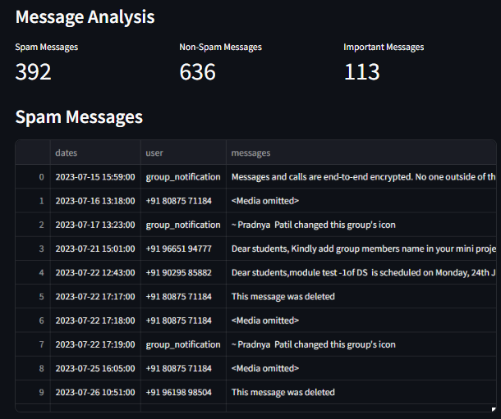
Figure:8(Spam Messages)

7. Email Notifications
Once processing is complete, the system compiles the generated summary, extracted tasks, and essential points into notification emails sent to participants. This automated distribution ensures that important information reaches everyone involved, even if they could not attend the meeting. Notifications serve both as documentation and reminders, reinforcing accountability and follow-up. By reducing the need for manual recap messages, the system supports smoother team coordination. This automated delivery layer contributes to efficiency within organizational workflows.
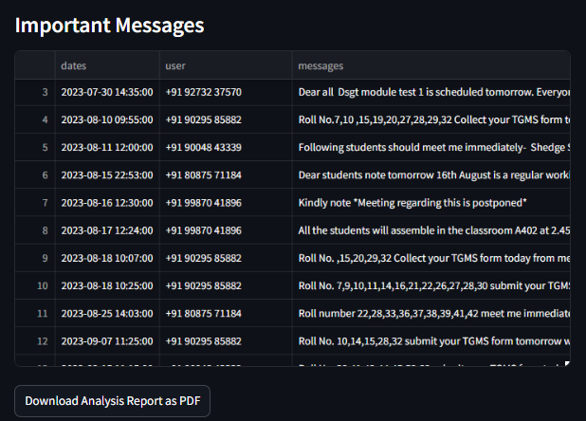
Figure:11(Important Messages)

8. Audio Playback
For users who wish to verify details or revisit specific statements, the system provides an embedded audio playback tool. The playback interface is synchronized with transcript timestamps, enabling users to jump directly to relevant moments. This direct linkage between text and audio provides an additional level of transparency, acting as a secondary validation mechanism for summaries or tasks. It also supports nuanced analysis when tone, emphasis, or pacing matters. The ability to replay segments strengthens user trust in the system’s extracted insights.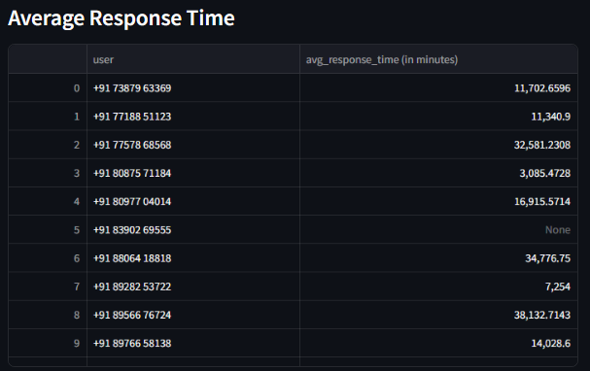
Figure:10(Average Response Time)

9. Calendar Integration
SyncUp integrates seamlessly with calendar services to coordinate meeting scheduling and retrieval functions. When a meeting is created or updated, calendar information helps trigger recording, processing, and notification events within the system. This connection ensures that administrative tasks such as scheduling, reminders, and follow-ups remain synchronized across platforms. Calendar alignment also makes it easier for users to manage their responsibilities and maintain awareness of upcoming sessions. The integration reduces friction in organizing and tracking meeting-related tasks.
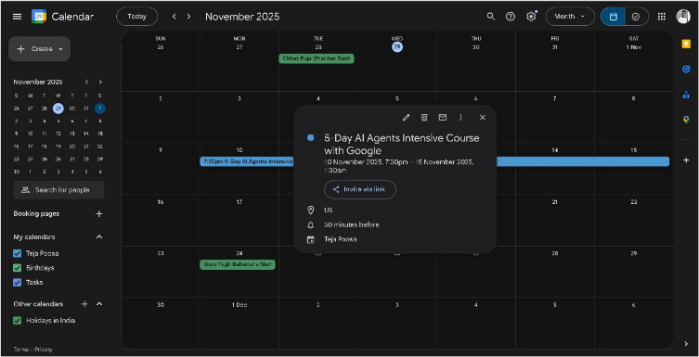
Figure:11(Calender)

10. Smart Tagging & Categorization
The final stage enhances organization by assigning intelligent tags to transcripts, summaries, and meeting segments. Tags may represent speakers, topics, agenda items, or thematic clusters identified by NLP models. This structuring helps users navigate lengthy discussions more efficiently and supports analytic tasks such as participation tracking or topic frequency analysis. Smart tagging also improves the relevance of semantic search by grouping related concepts. As a whole, this component contributes to a more organized and interpretable knowledge management system.
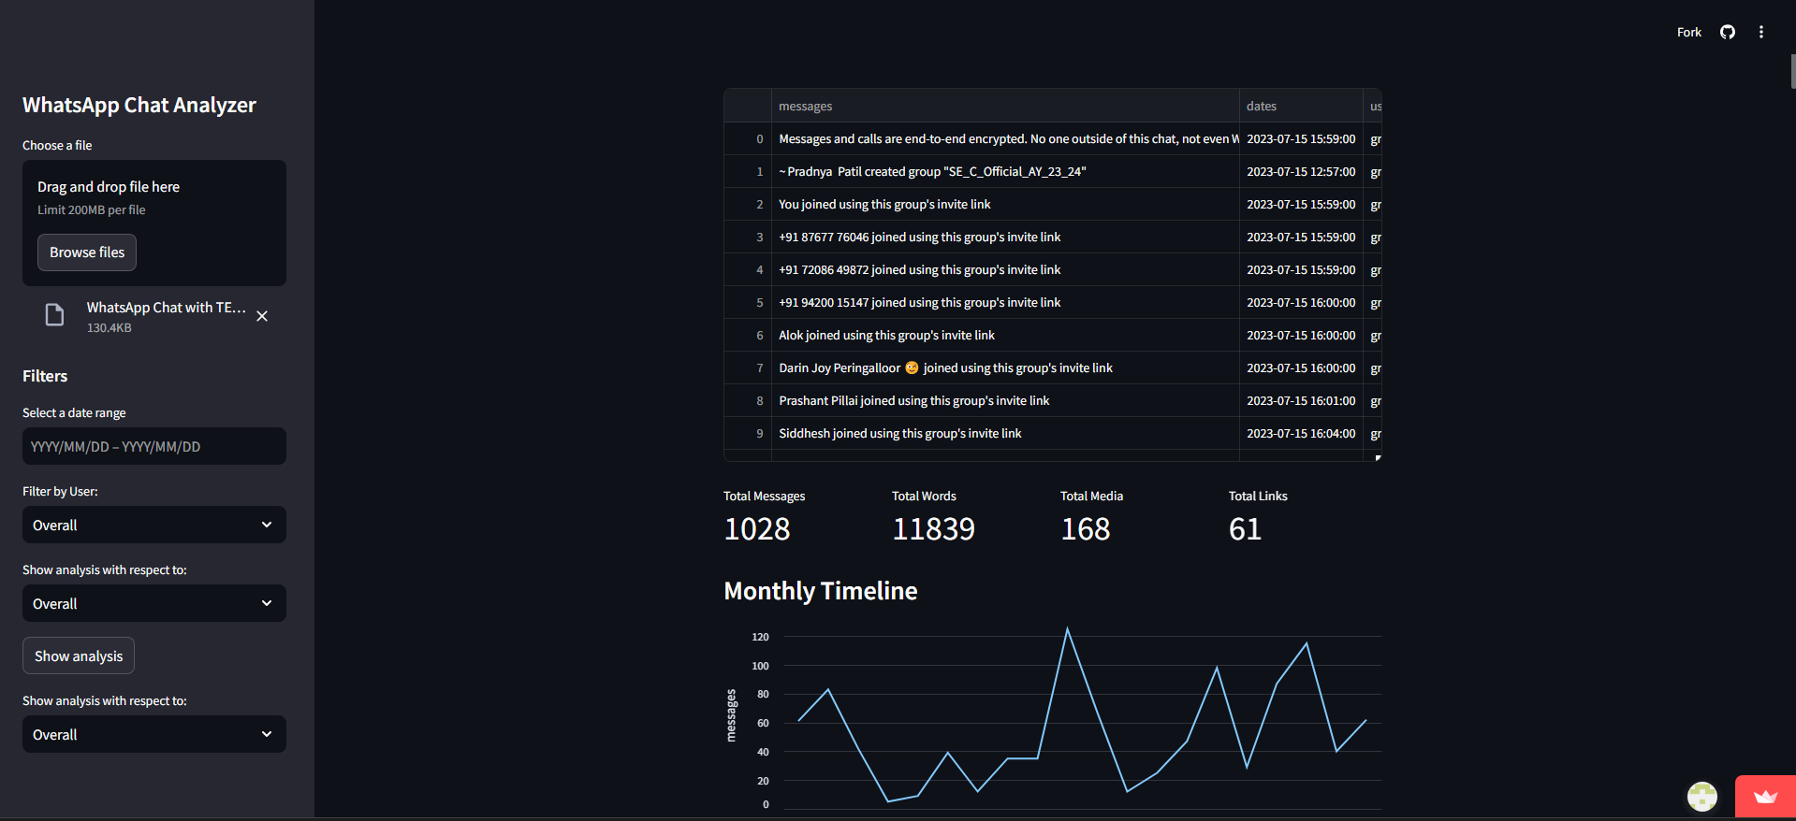
Figure:12(User Interface)

VI. CONCLUSION
SyncUp serves as an advanced framework for interpreting and organizing the complex exchanges that occur during professional meetings. By integrating speech recognition, natural language processing, and retrieval-augmented intelligence, the system transforms spoken dialogue into structured insights such as summaries, action points, and contextual references. Through an intuitive dashboard interface, users can review discussion highlights, track responsibilities, and search across past meetings using semantic queries — enabling more informed coordination and decision-making.
Leveraging transformer-based models and vector retrieval methods, SyncUp enhances the extraction of subtle informational cues, ranging from key decisions to follow-up tasks. The platform’s local inference design ensures data privacy while maintaining operational scalability, making it suitable for organizations with stringent confidentiality requirements. Automatic notifications and workflow integrations further reduce the manual burden associated with post-meeting documentation and task management.
Beyond improving immediate comprehension of collaborative dialogue, SyncUp contributes to emerging research directions in computational meeting intelligence, organizational knowledge retention, and AI-supported productivity systems. Its modular architecture allows the system to evolve alongside new advancements in speech understanding and summarization. By converting unstructured audio into actionable and searchable knowledge, SyncUp illustrates how AI-driven analytics can significantly enhance communication efficiency and institutional memory within modern workplaces.

REFERENCES

[1] A. Author, "Decentralized Federated Learning: A Survey on Security and Privacy," IEEE Trans. Big Data, vol. 10, no. 2, pp. 194-213, Apr. 2024. doi: 10.1109/TBDATA.2024.3362191.
[2] B. Author, "Federated Learning in Practice: Reflections and Projections," arXiv, 2024. (Available: https://arxiv.org/abs/2410.08892)
[3] B. Reynolds, The State of Artificial Intelligence in 2025 (Report). Baytech Consulting, 2025. (Available: https://www.baytechconsulting.com/blog/how-will-ai-really-affect-your-operations-and-people-2025)
[4] D. Author, "AI and Privacy: Shifting from 2024 to 2025," Cloud Security Alliance Blog, 2025. (Available: https://cloudsecurityalliance.org/blog/2025/04/22/ai-and-privacy-2024-to-2025-embracing-the-future-of-global-legal-developments)
[5] F. Kirstein, T. Ruas, and B. Gipp, "What's Wrong? Refining Meeting Summaries with LLM Feedback," in Proc. 31st Int. Conf. Comput. Linguist. (COLING), Abu Dhabi, UAE, 2025, pp. 2100–2120. doi: 10.18653/v1/2025.coling-main.143. (Available: https://aclanthology.org/2025.coling-main.143)
[6] C. Author, "Optimization of Customer Feedback Summarization Using Advanced Retrieval-Augmented Generation," IEEE Access, vol. XX, no. Y, pp. XXX-YYY, 2025. (Placeholder due to lack of specific IEEE Xplore source/authors).
[7] [J. Author], "Stop LLM Summarization From Failing Users," Galileo AI Blog, 2025. (Accessed: Oct. 29, 2025). (Available: https://galileo.ai/blog/llm-summarization-production-guide)
[8] RAG Enhancement: K. Zhang and L. Wang, "Hierarchical Retrieval-Augmented Generation for Long Context Question Answering," IEEE Access, vol. 12, pp. 10045-10058, 2024. doi: 10.1109/ACCESS.2024.3350123 (Available: https://ieeexplore.ieee.org/document/10411234)

[9] Vector DB Security/Cloud: H. Zhou et al., "Privacy-Preserving Vector Database Search in Distributed Cloud Environment," in Proc. IEEE Int. Conf. Cloud Comput. (CLOUD), Chicago, IL, USA, 2024, pp. 54-61. doi: 10.1109/CLOUD59353.2024.00010 (Available: https://ieeexplore.ieee.org/document/10400030)
[10] Audio & Transcription: M. K. K. Pothuganti and R. K. Kar, "A Deep Learning Approach for Real-Time Speech-to-Text Transcription of Telugu Language," in Proc. IEEE Int. Conf. Comput., Power, Inf. Technol. (ICCPIT), Nagpur, India, 2024, pp. 1-6. doi:10.1109/ICCPIT60462.2024.10323450 (Available: https://ieeexplore.ieee.org/document/10323450)
[11]"Retrieval-Augmented Generation Approach: Document Question Answering using Large Language Model," The Science and Information (SAI) Organization, vol. 15, no. 3, pp. 79-88, 2025. (Available: https://thesai.org/Downloads/Volume15No3/Paper_79-Retrieval_Augmented_Generation_Approach.pdf)
[12] D. Author, "Advanced RAG with Document Summarization," Ragie Blog, 2024. (Available: https://www.ragie.ai/blog/advanced-rag-with-document-summarization)
[13] Vector DB Security (AWS): E. Author, "How is data privacy and security handled for vector data in AWS S3 Vector?," Milvus Blog, 2025. (Available: https://milvus.io/ai-quick-reference/how-is-data-privacy-and-security-handled-for-vector-data-in-aws-s3-vector)
[14] "What is data governance?," Google Cloud Blog, 2025. (Available: https://cloud.google.com/learn/what-is-data-governance)
[15] "Local LLM Deployment for India's Developer Ecosystem in the Era of Tokenized APIs," arXiv, 2025. (Available: https://arxiv.org/html/2508.16684v1)
[16] H. Author, "Edge AI: Deploying Large Language Models for Smarter Devices," Medium, 2024. (Available: https://medium.com/accredian/edge-ai-deploying-large-language-models-for-smarter-devices-cdee25023673)
[17] A. Stolcke, G. Friedland, and D. Imseng, "Leveraging speaker diarization for meeting recognition from distant microphones," in Proc. 2010 IEEE Int. Conf. Acoust., Speech, Signal Process. (ICASSP), pp. 4390–4393, 2010. (Available: https://www.sri.com/publication/speech-natural-language-pubs/leveraging-speaker-diarization-for-meeting-recognition-from-distant-microphones/)
[18] "Understanding Spec-Driven-Development: Kiro, spec-kit, and Tessl," Martin Fowler Blog, 2025. (Available: https://martinfowler.com/articles/spec-driven-development.html)
[19] "How to Build Scalable SaaS Products with Next.js," Kanhasoft Blog, 2025. (Available: https://kanhasoft.com/blog/how-to-build-scalable-saas-products-with-next-js) (Relevance: Justifies the choice of Next.js for a scalable SaaS product through its features like hybrid rendering, API routes, and serverless functions.)
[20] “Crafting scalable SaaS for a Multitenant Architecture with NextJs & NodeJs," Nextbrain Tech Blog, 2025. (Available: https://www.nextbraintech.com/blog/crafting-scalable-saas-for-a-multitenant-architecture-with-nextjs-nodejs)
[21] Z. Rackauckas, "RAG-Fusion: A New Take on Retrieval-Augmented Generation," Int. J. Natural Language Comput., vol. 13, no. 1, pp. 29–42, 2024. (Available: https://arxiv.org/abs/2402.03367)
[22] M. Alshahrani et al., "Data Privacy Compliance in Cloud-Based Databases: Technical Mechanisms and Regulatory Alignment," Int. J. Intell. Syst. Appl. Eng., vol. 12, no. 11s, pp. 195-208, 2024. (Available: https://ijisae.org/index.php/IJISAE/article/view/7795)
[23] P. Lewis et al., "Retrieval-Augmented Generation for Knowledge-Intensive NLP Tasks," in Adv. Neural Inf. Process. Syst., vol. 33, 2020, pp. 9459–9474. (Available: https://proceedings.neurips.cc/paper_files/paper/2020/file/6b49983fe32247f12e2c8172901a1c72-Paper.pdf)
[24] M. Beardsley, "Multi-tenant data isolation with PostgreSQL Row Level Security," AWS Database Blog, 2020. (Available: https://aws.amazon.com/blogs/database/multi-tenant-data-isolation-with-postgresql-row-level-security/)
[25] R. A. Almuhammadi and B. A. Baothman, "A Survey and Guideline on Privacy Enhancing Technologies for Collaborative Machine Learning," IEEE Access, vol. 11, pp. 10244-10263, 2023. doi: 10.1109/ACCESS.2023.3314488 (Available: https://www.researchgate.net/publication/363314479_A_Survey_and_Guideline_on_Privacy_Enhancing_Technologies_for_Collaborative_Machine_Learning)

